

|  |
| --- |
|  |

Quadcopter and state of the art camera

# Executive summary

T

he current consumer electronics market is experiencing unprecedented change—and with that changes comes great opportunity. Together, Contoso’s camera division and it’s Adventure Works quadcopter division are ideally poised to take a market leadership position and deliver quality, consistency, and innovation to there customers.

Increasingly, photography is chaning. People live their life with a camera in hand and sales of traditional cameras are in decline. At the same time, a number of amazing technology enhancements have brought quadcopter technology to the masses, creating a new platform for digal photography. The industry challenge remains clear: Understand your customers, anticipate their future requirements, and meet their needs.

That’s why a combination of our camera technology and quadcopter technology makes sense. No one in the consumer electronics market has a better understanding than Contoso of its long history of exciting innovation, turbulent disruption, and remarkable growth. And no one in the market consistently navigates through these changes and empowers its partners like Contoso. From policemen to everyday users, our products will lead the market.

# Why Contoso camera technology?

Of all the camera and quadcopter and UAV companies out there, what makes Contoso different? Four key points, discussed in more detail below, prove how our partnership would be unique and powerful:

* Customer-focused approach.
* Award winning camera technlogy.
* Aligned priorities and goals.
* We belveiee in our experience.

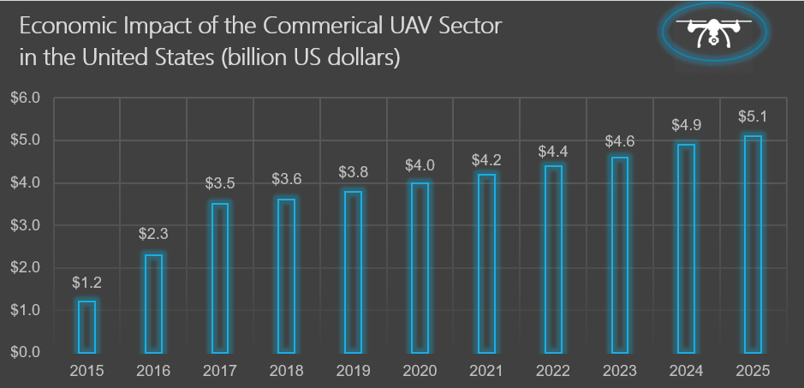   
 **Figure 1**: Sales projections, 2015-2025

## Contoso Technology Leadership

Contoso camera technology has lead the market for over 7 years, and in combination with our Quadcopter technology, offers an outstanding prospect for market dominance in both the recreation and commercial application markets.

Notre technologie Quadcopter est basée sur 10 ans de recherche et développement, dans le cadre d'un effort coordonné à travers nos équipes mondiales.  Nous avons 14 brevets dans ce domaine, et nous avons déjà investi **plus de 600 millions de dollars**.

<ADD GRAPHIC SHOWING R&D SPEND>

The Quadcopter market has grown significantly in the past 10 years, and it is an exciting time, much like the auto industry in the early days of Ford and General Motors.

<ADD MARKET AND HISTORICAL BACKGROUND>

Figure 2 below shows Contoso’s dominance in the camera space as well as the growth and quality of Contoso’s quadcopter business. D

**Figure 2**: Statistics on Contoso Camera Technology as of Feb 14, 2018

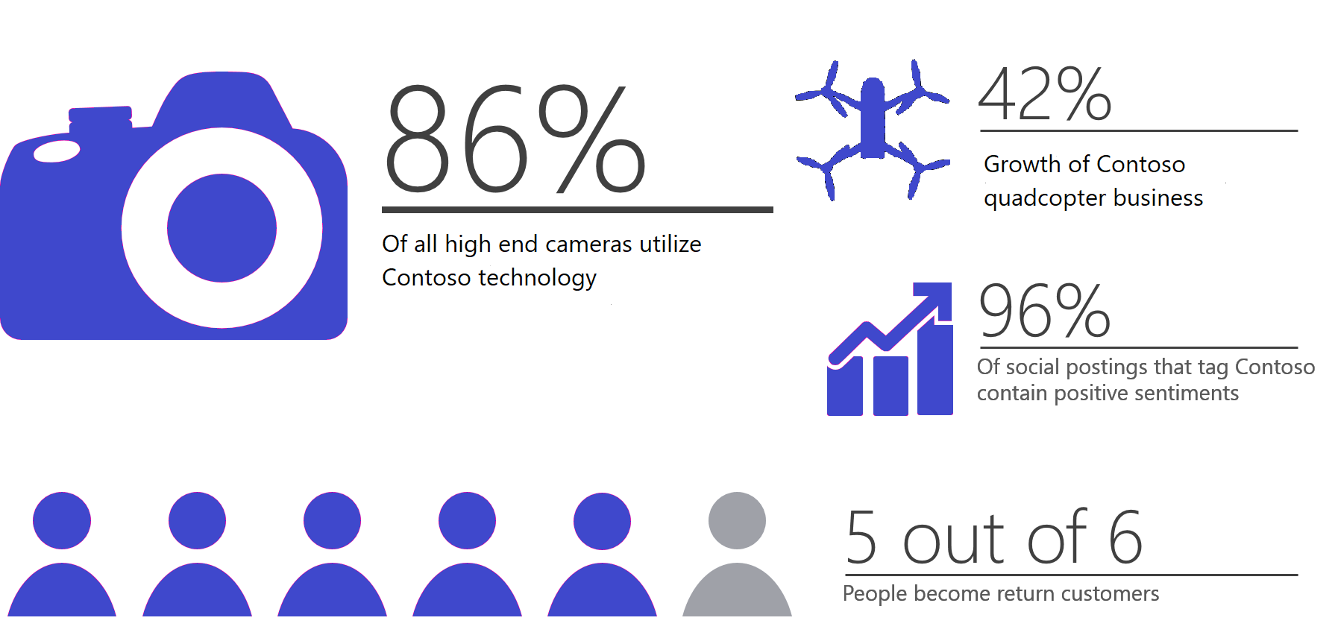

Just last quarter, Contoso experienced strong sales across all of its consumer electronics divisions, as evidenced below in Figure 3, below.

|  |  |  |  |
| --- | --- | --- | --- |
| **Category** | **Avg unit price** | **Units sold** | **Total Sales** |
| **Audio** | $146.06 | 18,415 | $1,954,835 |
| **Cameras & Camcorders** | $210.85 | 13,697 | $4,036,608 |
| **Cell Phones** | $47.66 | 38,506 | $354,286 |
| **Computers** | $173.27 | 19,323 | $2,202,471 |
| **Quadcopters** | $742.59 | 2,395 | $1,409,945 |
| **TV & Video** | $421.46 | 7,589 | $2,752,893 |
| **Contoso sales totals** | $299.84 | 99,925 | $12,711,041 |

**Figure 3:** Contoso quarterly sales, by division

Ma va oltre le vendite-Contoso offre ***innovative***, ad **alta qualita** prodotti. Nel 2018 da soli, abbiamo programmato di lanciare diversi prodotti innovativi nel nostro televisore e mercati audio Home.

## Our priorities are your priorities

Contoso is a company that stands on its priorities. That’s why partnership with Adventure Works makes sense; Contoso business priorities map directly to Adventure Works’s business goals. Our commitment to quality, consistent innovation and thought leadership, and engagement with the larger community resonate in tune with how Adventure Works does business (Figure 4).

**Figure 4**: Alignment of business priorities and goals

|  |  |
| --- | --- |
| **Contoso business priority** | **Adventure Works business goals** |
| **Commitment to quality** | Deliver a solid, dependable product that customers can rely on. |
| **Consistent innovation and thought leadership** | Deliver a progressive, modern experience that customers want to keep coming back to. |
| **Community and sustainability** | Leave a positive impact on the community and environment. |

## Customer-focused approach

Contoso has a 30-year history of excellence in the consumer electronics space, consistently giving buyers what they want: innovative, high-quality products for competitive prices from companies they know and trust. Contoso has a solid reputation; in fact, across Twitter trends from 2012-2013, the company was highly correlated with positive word associations among users who tagged *Contoso*. Worldwide sales numbers validate this approach as well—Contoso products comprised 39% of worldwide television sales last year (Figure 5).

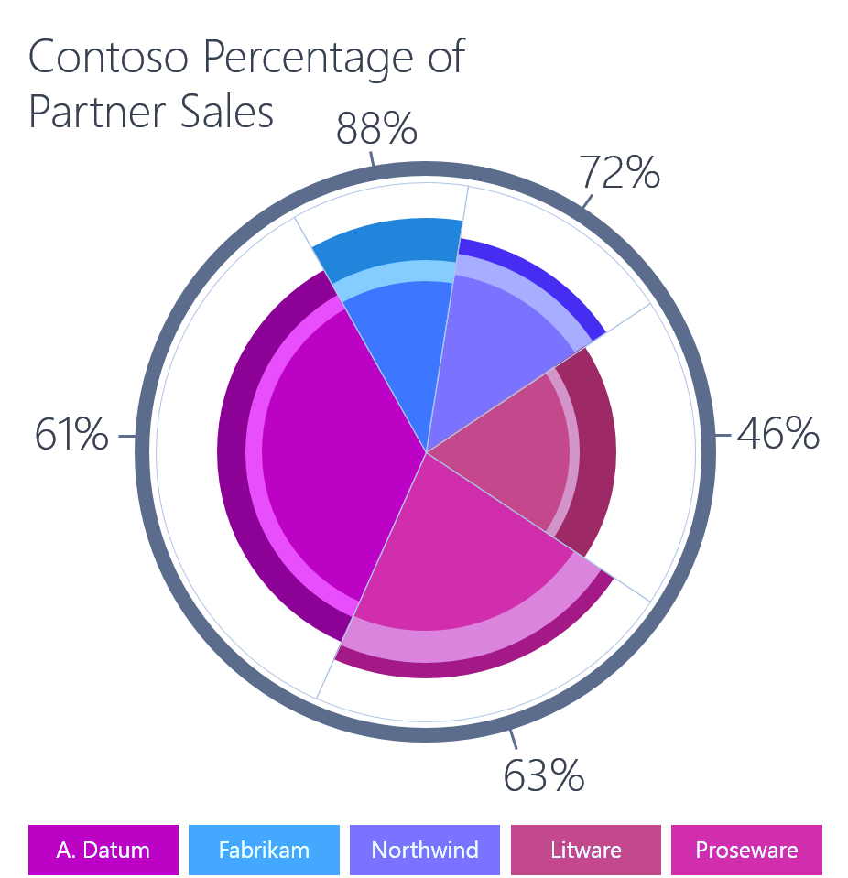

**Figure 5**: Worldwide television sales percentages for 2012-2013

At Contoso, customer satisfaction is a guiding value, and the social media feedback shows that we take this value seriously. Want a deeper level of customer engagement and satisfaction? That’s what Contoso can help provide.

# The sales alignment process

In this analysis, we have established that Adventure Works and Contoso share aligned business priorities and goals. We’ve also briefly reviewed the Contoso track record of success with past sales partner relationships. Now let’s take a look at the sales alignment process itself. When you partner with Contoso in today’s market, what can you expect?

## The approach

Here’s more good news: We have simplified our process for integrating with your business. The step-by-step partnership approach is organized in three phases: evaluate, plan, and execute & measure (Figure 5). Each is intended to build directly on the phase before it. All are designed to be straightforward and easy to enact. Please note that each phase is more thoroughly documented in the supplemental materials provided by Katie Jordan.

|  |  |
| --- | --- |
| EvaluateIn this phase, Contoso works with you to identify key strategic alignment areas, opportunities for collaboration, and potential new offerings. | Plan  Once we’ve identified the targets, Contoso representatives will organize the timelines and commitments for the proposed approach. |
| Execute & Measure  In this phase, the plan is carried out and the potential benefits are realized. Next steps… | |

It’s time to start working—together. Katie Jordan will contact you in the next few days to talk about next steps and the proposed approach. If you’d like to start sooner or want additional information, please contact [katiej@contoso.com](mailto:katiej@contoso.com) to learn more.